BIT 4107 – Mobile Application Development
ENHANCED PROFESSIONAL STUDENT LOGBOOK
Student Name: Risper Chepngeno
Admission Number: BIT/2024/55500
School/Faculty: Computing and Informatics
Programme: Information Technology
Academic Year: 3
Semester: 2
Lecturer: Mr nyoro
Phone Number: 0794038472

Instructions
This logbook is used to document weekly learning activities, practical exercises, skills acquired, challenges encountered, solutions applied, and reflections. Students should complete all sections every week.
Each week to follow remarks in week 1 section.

Autogenerated Table of content

Week 1: Introduction to Mobile Application Development
Tools/Software Used
Visual Studio code (VS Code):
Flutter SDK with Dart programming language
Google chrome browser-as runtime device simulation target
Figure1.1: Terminal Environment Output Displaying Verified Flutter and Dart Version Specifications
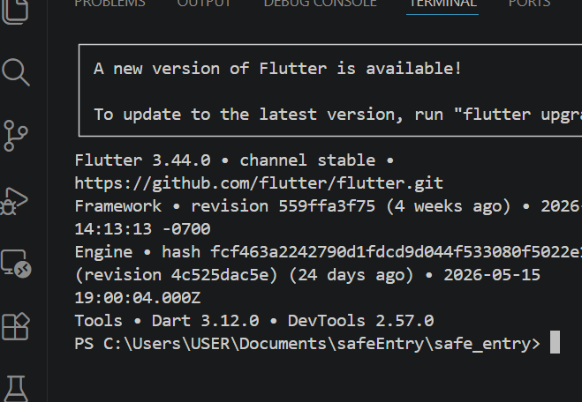

Practical Activities Undertaken
only screenshots needed and labeling
Screenshots/Evidence Attached (Yes)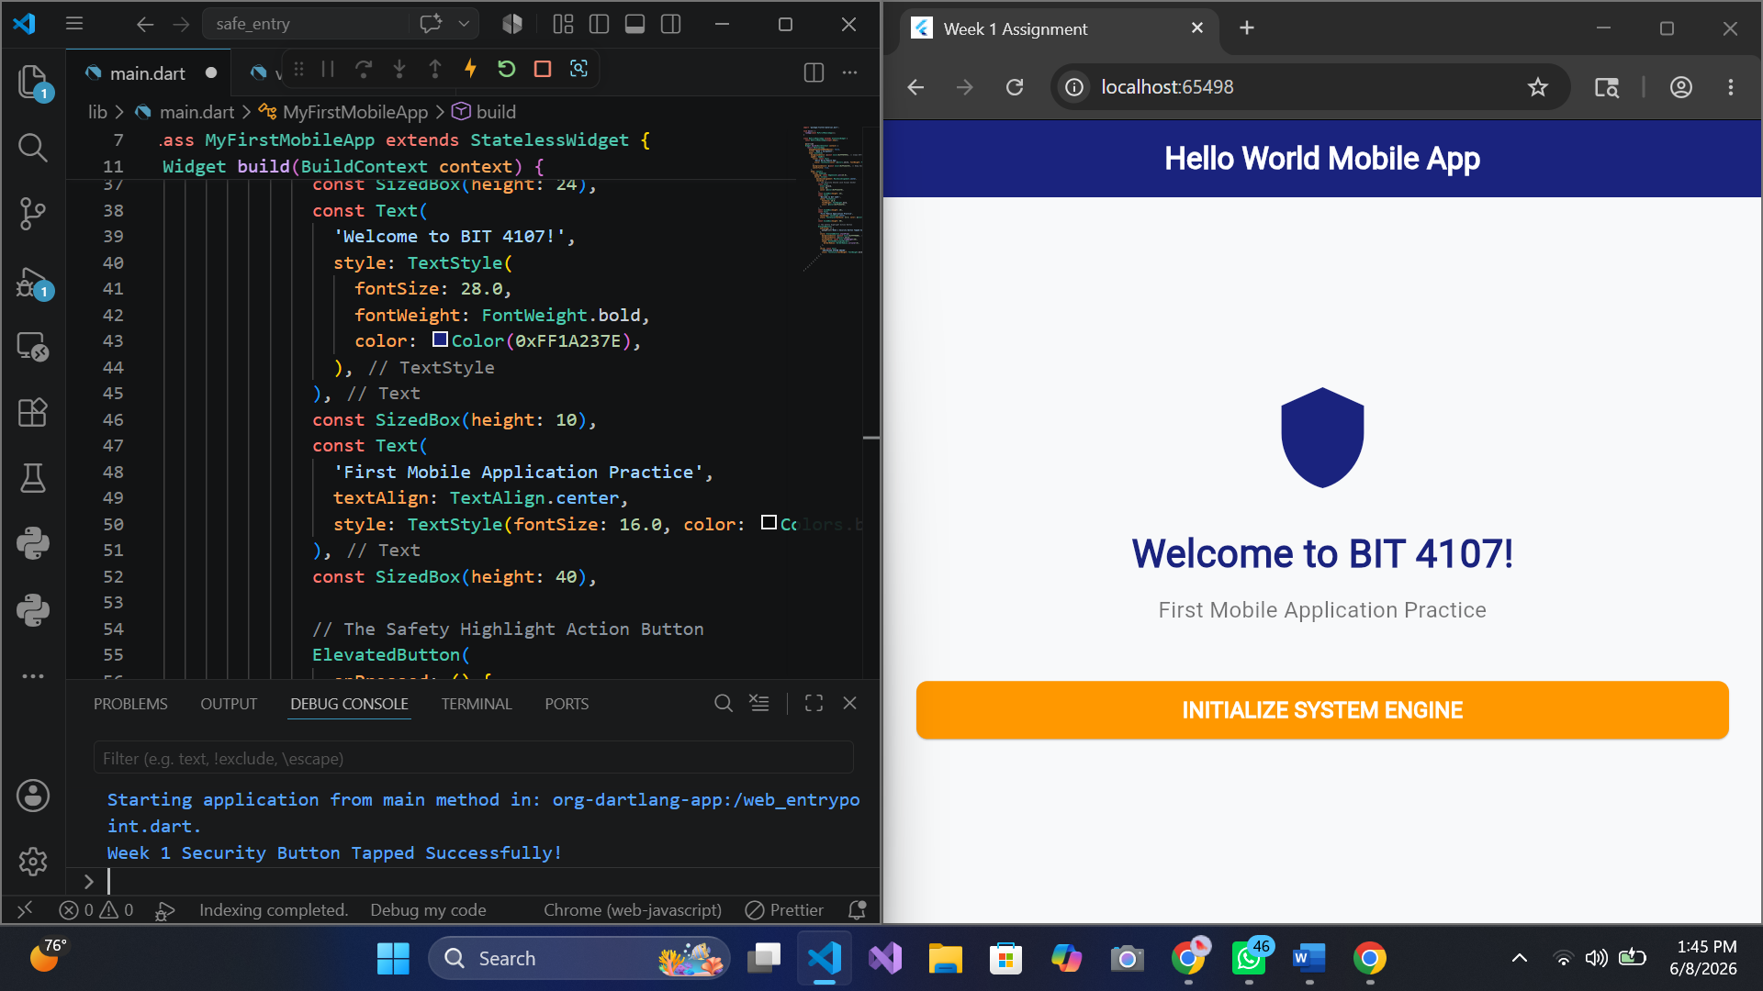
Figure 1 : system initialization
Personal Reflection

At first, I really struggled getting the system path to find Flutter, which was very frustrating. But fixing those VS Code errors—like deleting the broken widget_test.dart file and switching print to debugPrint—actually taught me how to debug terminal warnings. Seeing my navy shield and orange button finally light up on the screen was a real breakthrough
Week 2: Mobile Development Environment
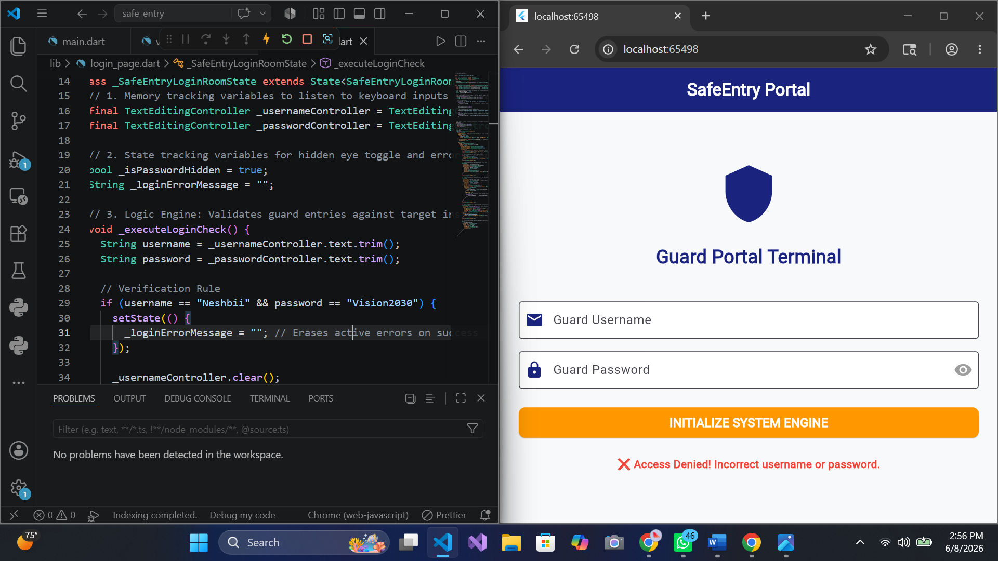
Figure 2.1 login page

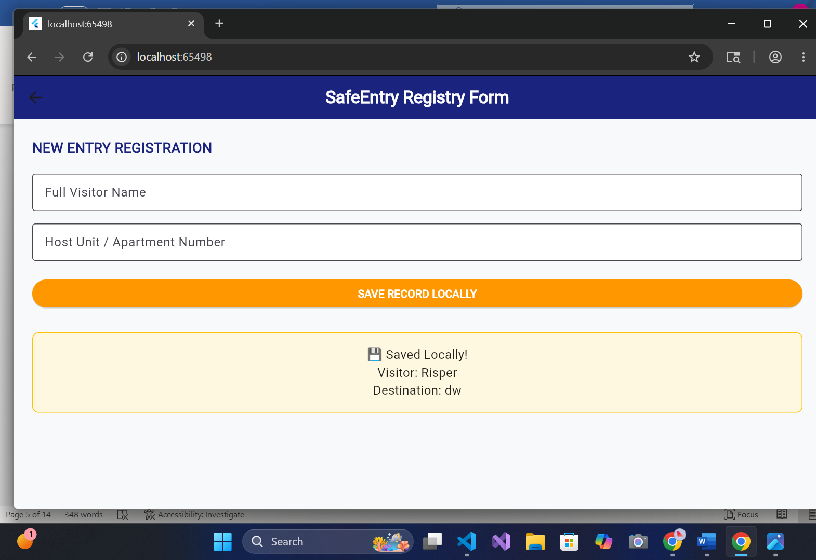
Figure 3.2 registration page
Personal reflection
I practiced on the syntax of dart language. It is similar to c and java so it did not take much of my time. being able to came up with the screens and navigate through it is worth it

Week 3: User Interface Design

Same as week 1
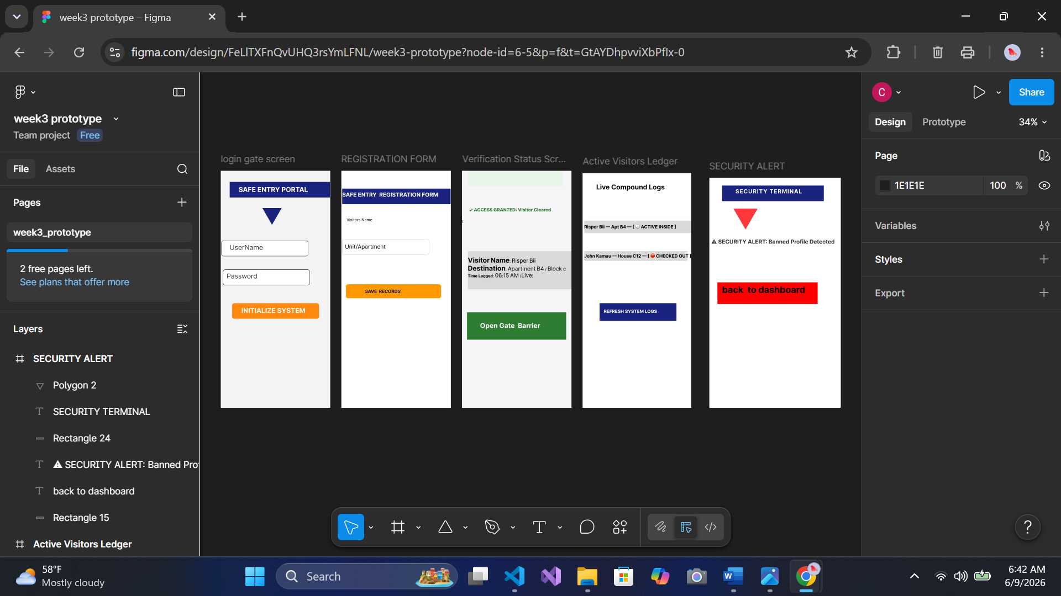
Figure 4.1 Figma design
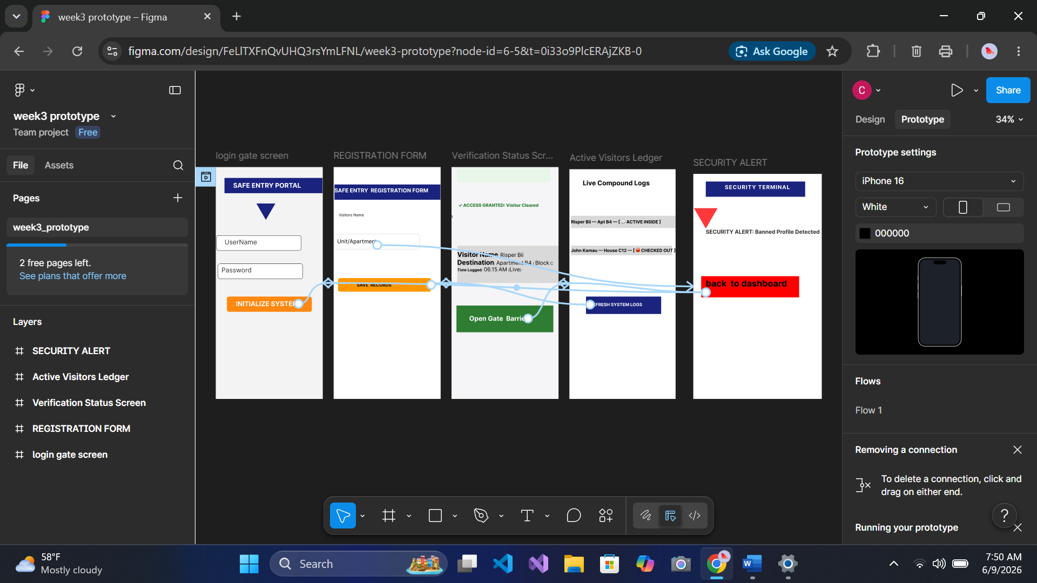
Figure 5.1: prototype linking of screens

.
Figure 6.2 Figma Visual Interactive Prototype Wire Map Displaying Core Navigation Layout Flows and Brand System Themes
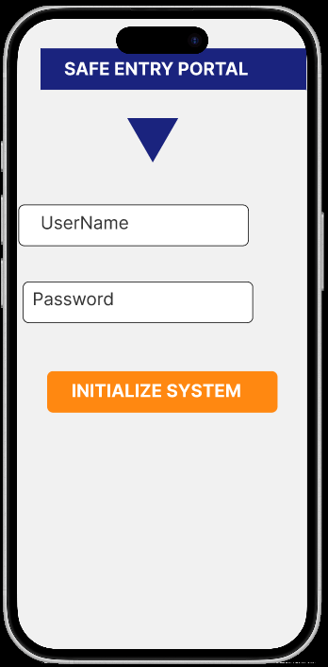
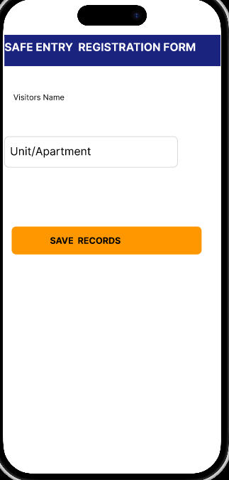

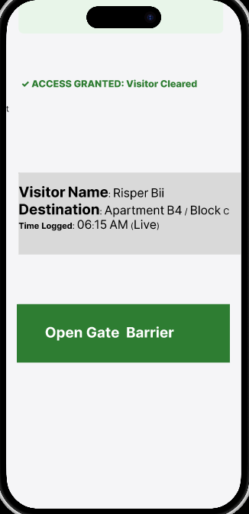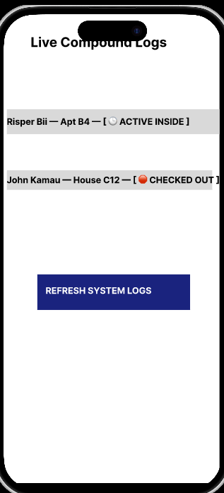
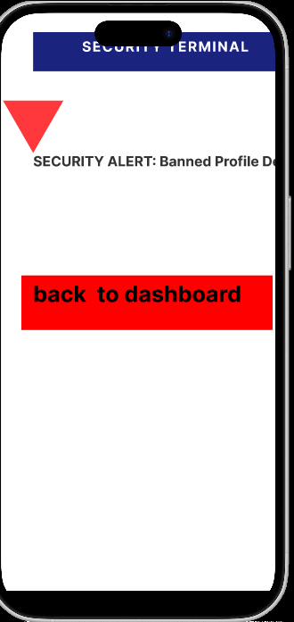

Week 4: Event Handling and User Interaction

Same as week 1
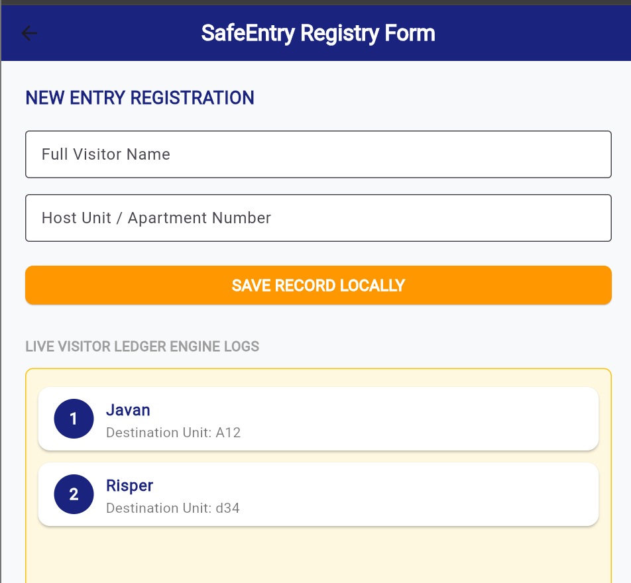
Figure 6.1:live Application Workspace Displaying Multi-visitor Registry With Sequential list Numbering
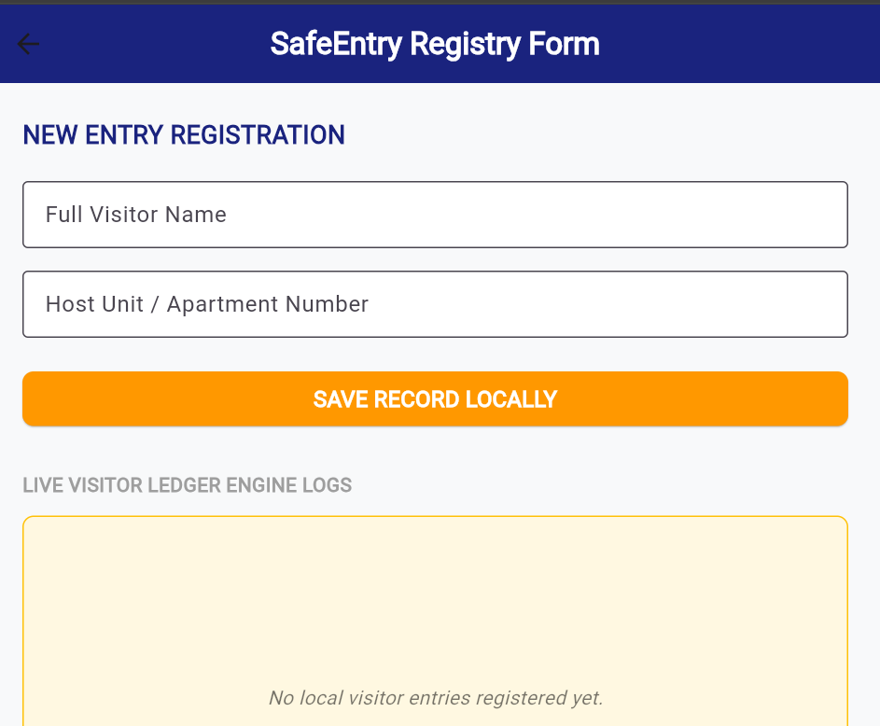
Figure 6.2 UI Form Interface Displaying Automated Text Field Sanitization and Clearance Post-Event Execution
Personal reflection
Working on event handlers and data saving this week is a big learning experience for me. At start I hit several bugs. The main challenge was the backward numbering issue of visitors, I fixed it by using index+1(incrementing), At last the SafeEntry registry finally works perfectly

Week 5: Data Management

Same as week 1
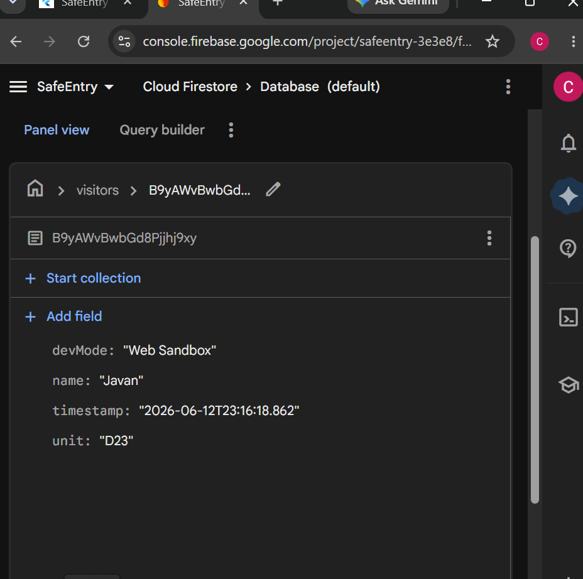
Figure 7The Firebase Console Live Data Grid (The Cloud Proof)
Personal Reflection:
Connecting my app to Google Firebase this week was a great learning experience. The trickiest part was fixing a windows permission issue that kept freezing my Google Chrome browser when I added the new cloud packages. I solved this by turning on Developer Mode in my system settings to clear the compiler link. Once I added my unique connection keys and set up the cloud database, watching my test visitor logs instantly pop up on the online Firebase grid in real-time was amazing. This week taught me how cloud data streams work,

Week 6: Networking and APIs

Same as week 1
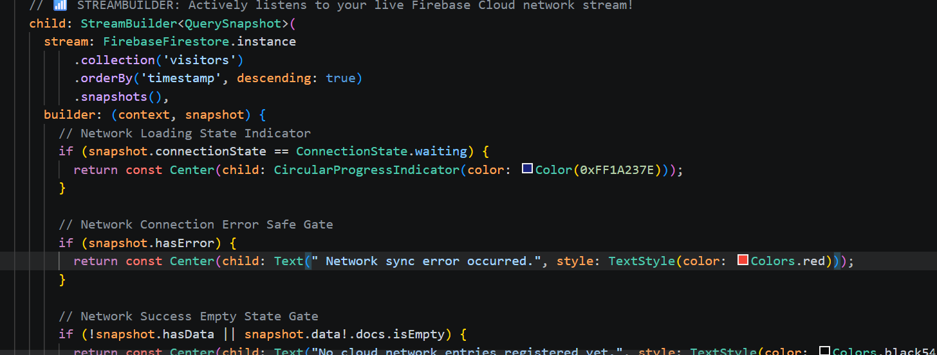
Figure 8 networking code

Week 7: Application Architecture

Same as week 1

Week 8: Project Planning

Week 9: Device Features and Sensors

Same as week 1

Week 10: Notifications and Background Services

Same as week 1

Week 11: Mobile Security

Same as week 1

Week 12: Testing and Debugging

Same as week 1

Week 13: Application Deployment

Same as week 1

Week 14: Final Project Presentation

Same as week 1

Semester Project Tracking

Project Title

Project Objectives

Project Requirements

Development Milestones

Testing Results

Lessons Learned

Future Improvements

End of Semester Reflection

Summary of Skills Acquired

Most Interesting Topic

Major Challenges Faced

How Challenges Were Overcome

Professional Growth Achieved

Overall Course Experience

Final Approval
Student Name: __________________________
Student Signature: ______________________
Date: _________________________________
Lecturer Name: _________________________
Lecturer Remarks: _____________________
Date: _________________________________

